Taylor Sisti & Tyler Bell

CENG340: Environmental

September 17, 2013

Lab 3 – Nonlinear Curve Fitting

PART I

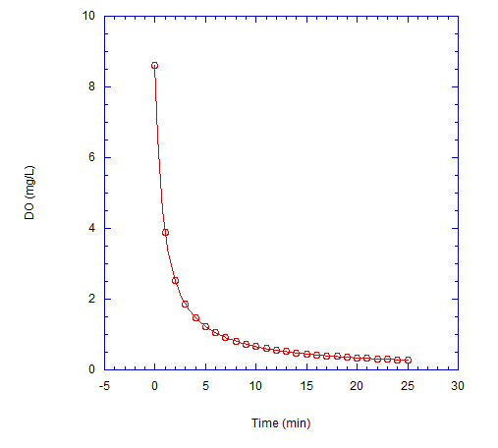

$$k=0.14 \frac{L}{mg*min}$$

**Figure 1**. Data set 1 is a second order reaction that plots dissolved oxygen (DO) vs. time in minutes. The reaction rate coefficient is displayed on the graph along with its model fit.

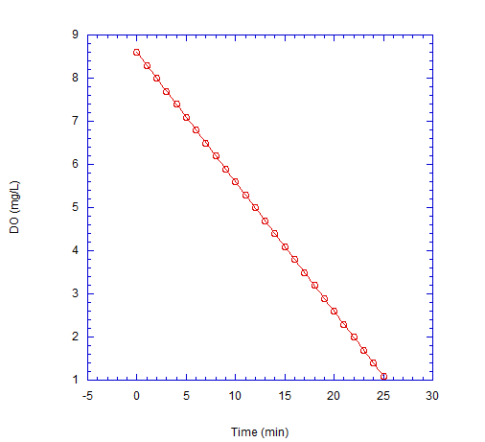

$$k=0.3 \frac{mg}{L*min}$$

**Figure 2**. Data set 2 is a zero order reaction that plots dissolved oxygen (DO) vs. time in minutes. The reaction rate coefficient is displayed on the graph along with its model fit.

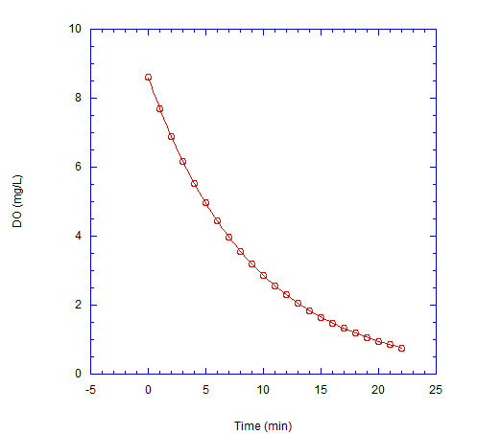

$$k=0.11 \frac{1}{min}$$

**Figure 3**. Data set 3 is a first order reaction that plots dissolved oxygen (DO) vs. time in minutes. The reaction rate coefficient is displayed on the graph along with its model fit.